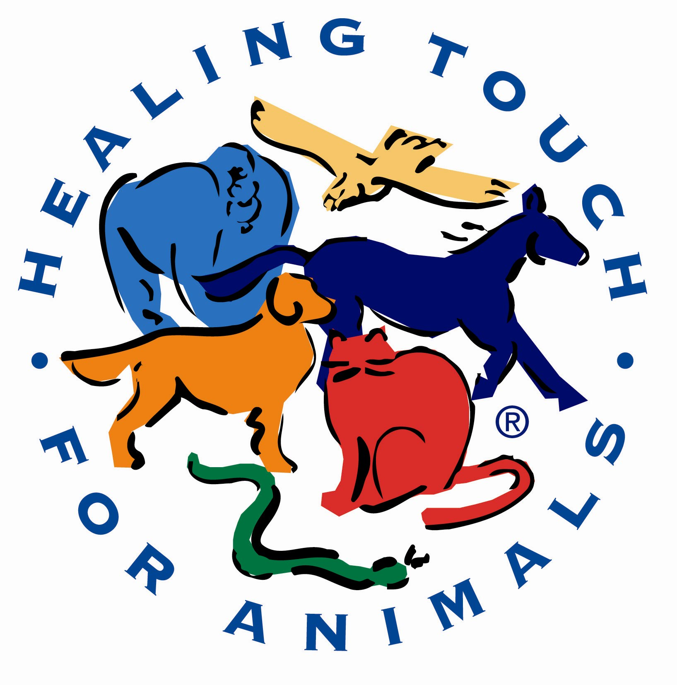 | HEALING TOUCH FOR ANIMALS®  Level 1 • CITY, STATE  DATES
Instructor
Carol Komitor
PO Box 632171
Highlands Ranch, CO 80163-2171
Info@HealingTouchforAnimals.com
303-470-6572
Coordinator

